Area of a Circle  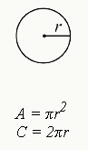 | Area of a Circle  - π is a constant that can, for the purposes of the SAT, be written as 3.14 (or 3.14159)  - r is the radius of the circle (any line drawn from the center point straight to the edge of the circle)
Circumference of a Circle  C=2πr (or C=πd) | Circumference of a Circle  - is the diameter of the circle. It is a line that bisects the circle through the midpoint and touches two ends of the circle on opposite sides. It is twice the radius.
Area of a Rectangle  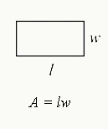  A=lw | Area of a Rectangle  A=lw  - l is the length of the rectangle  - w is the width of the rectangle
Area of a Triangle  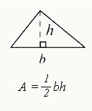 | Area of a Triangle  - b is the length of the base of triangle (the edge of one side)  - h is the height of the triangle  In a right triangle, the height is the same as a side of the 90-degree angle. For non-right triangles, the height will drop down through the interior of the triangle, as shown above.
The Pythagorean Theorem  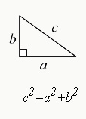  a2+b2=c2 | The Pythagorean Theorem  - In a right triangle, the two smaller sides (a and b) are each squared. Their sum is the equal to the square of the hypotenuse (c, longest side of the triangle).
Properties of Special Right Triangle: 30, 60, 90 Degree Triangle  The side lengths are determined by the formula: x, x√3, and 2x  The side opposite 30 degrees is the smallest, with a measurement of x.  The side opposite 60 degrees is the middle length, with a measurement of x√3.  The side opposite 90 degree is the hypotenuse (longest side), with a length of 2x.  For example, a 30-60-90 triangle may have side lengths of 5, 5√3, and 10. | Properties of Special Right Triangle: 30, 60, 90 Degree Triangle  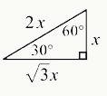
Properties of Special Right Triangle: Isosceles Triangle  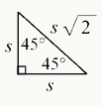 | Properties of Special Right Triangle: Isosceles Triangle  - An isosceles triangle has two sides that are equal in length and two equal angles opposite those sides.  - An isosceles right triangle always has a 90-degree angle and two 45 degree angles.  The side lengths are determined by the formula: x, x, x√2, with the hypotenuse (side opposite 90 degrees) having a length of one of the smaller sides *√2.
Volume of a Rectangular Solid  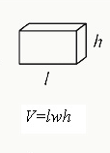 | Volume of a Rectangular Solid  - l is the length of one of the sides.  - h is the height of the figure.  - w is the width of one of the sides.
Volume of a Cylinder  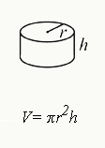 | Volume of a Cylinder  - r is the radius of the circular side of the cylinder.  - h is the height of the cylinder
Volume of a Sphere  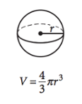 | Volume of a Sphere  - r is the radius of the sphere.
Volume of a Cone  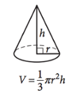 | Volume of a Cone  - r is the radius of the circular side of the cone.  - h is the height of the pointed part of the cone (as measured from the center of the circular part of the cone).
Volume of a Pyramid  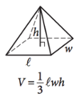 | Volume of a Pyramid  - l is the length of one of the edges of the rectangular part of the pyramid.  - h is the height of the figure at its peak (as measured from the center of the rectangular part of the pyramid).  - w is the width of one of the edges of the rectangular part of the pyramid.
Geometry Laws  Law # 1  Law # 2  Law # 3 | Law #1: the number of degrees in a circle is 360  Law #2: the number of radians in a circle is 2π  Law #3: the number of degrees in a triangle is 180
Slope Formula | Slope Formula  - Given two points, A(x1,y1),B(x2,y2), find the slope of the line that connects them:  (y2−y1)  (x2−x1)  - The slope of a line is the  rise(verticalchange)  run(horizontalchange)
How to Write the Equation of a Line  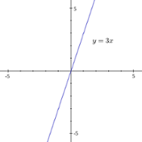 | How to Write the Equation of a Line  - y=mx+b (If you get an equation that is NOT in this form (ex. mx−y=b), then re-write it into this format!)  - m is the slope of the line.  - b is the y-intercept (the point where the line hits the y-axis).  - If the line passes through the origin (0,0), the line is written as y=mx.
Midpoint formula  Given two points, A(x1,y1), B(x2,y2), find the midpoint of the line that connects them: | Midpoint formula  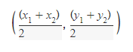
Distance formula  - Given two points, A(x1,y1),B(x2,y2), find the distance between them: | Distance formula  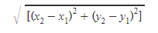
Length of an arc  - Given a radius and a degree measure of an arc from the center, find the length of the arc  - Use the formula for the circumference multiplied by the angle of the arc divided by the total angle measure of the circle (360) | Length of an arc  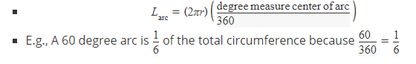
Area of an arc sector  - Given a radius and a degree measure of an arc from the center, find the area of the arc sector | Area of an arc sector  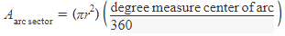
Quadratic equation  - Given a polynomial in the form of ax2+bx+c, solve for x. | Quadratic equation  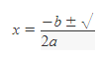  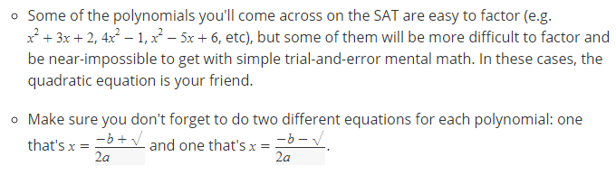
Probability of an outcome | Probability of an outcome  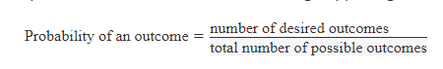
PERCENTAGES  - Find x percent of a given number n. | PERCENTAGES  Find x percent of a given number n.  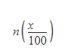
PERCENTAGES  - Find out what percent a number n is of another number m. | PERCENTAGES  - Find out what percent a number n is of another number m.  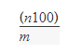
PERCENTAGES  - Find out what number n is x percent of. | PERCENTAGES  - Find out what number n is x percent of.  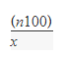
Trigonometry  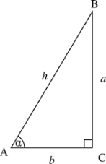  - Find the sine of an angle given the measures of the sides of the triangle | Trigonometry  Find the sine of an angle given the measures of the sides of the triangle.  sin(x)= Measure of the opposite side to the angle / Measure of the hypotenuse  In the figure above, the sine of the labeled angle would be a/h
Trigonometry  - Find the cosine of an angle given the measures of the sides of the triangle. | Trigonometry  cos(x)= Measure of the adjacent side to the angle / Measure of the hypotenuse  In the figure above, the cosine of the labeled angle would be b/h
Trigonometry  - Find the tangent of an angle given the measures of the sides of the triangle. | Trigonometry  tan(x)= Measure of the opposite side to the angle / Measure of the adjacent side to the angle  In the figure above, the tangent of the labeled angle would be a/b
Trigonometry  SOHCAHTOA | Trigonometry  Sine equals Opposite over Hypotenuse  Cosine equals Adjacent over Hypotenuse  Tangent equals Opposite over Adjacent
Probability  calculate how likely it is that a white marble would be drawn from a jar that contains three white marbles and four black marbles, it's easy enough to realize you need to take this probability formula: | Probability  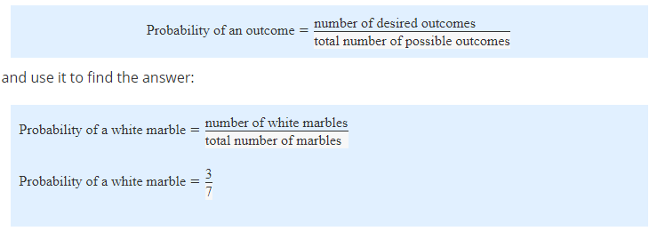
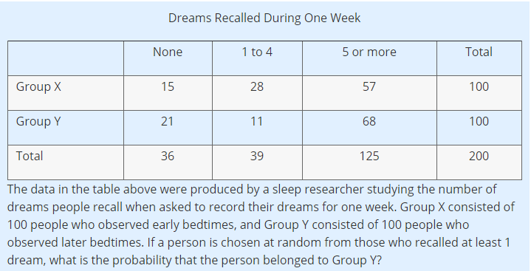 | 